Project Meeting 2 Agenda

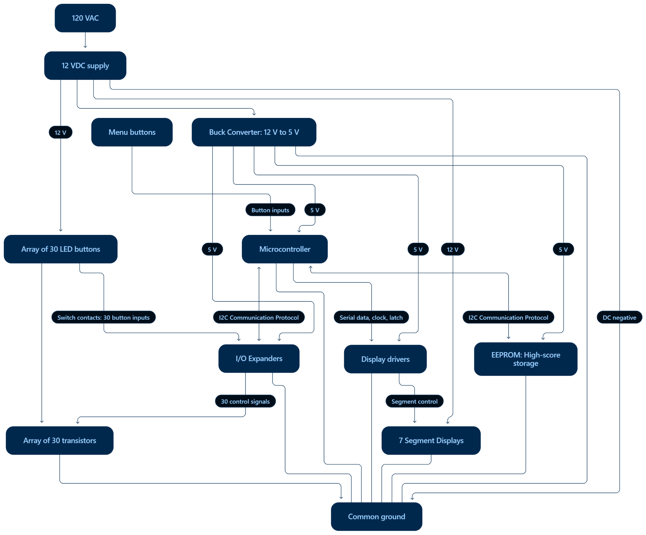
- Discuss any other project ideas or ideas to implement into the arcade project
- Define the project
  - States (idle, easy/hard mode)
  - How points will be calculated
  - How many control buttons will there be (start, 2 player, different mode)
  - Audio
- An introduction on how each part of how the project works:
Arcade Game IEEE 2026-2027.docx

